SKULL-METAPODIALS CORRELATIONS

**Basilar Length (BL) and Metapodial articular and supra-articular breadths (MC10, MC11, MT10, MT11)**

It may be useful to know what metapodials are likely to belong with a given size of skull. Figure 1 shows how distal breadths of MC and MT are related to cranial basilar lengths on extant Equus. In most Asinines, Hemionines, Mountain Zebras, and Grevy’s Zebras the proportions are roughly similar. Most Przewalski horses and Plain Zebras have relatively wider metapodials. All data for each group may be found in corresponding sheets of Table 1.

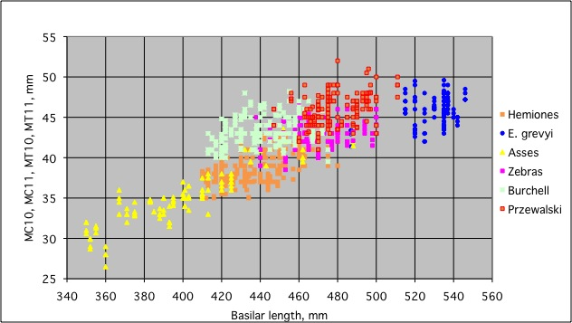

Figure 1

The sheets of Table 2 show separatedly the proportions for basilar lengths and MC 10, MT 10 (distal supra-articular breadths), MC 11 and MT 11 (distal articular breadths).

Differences between Plain zebras and Przewalski horses on one side and the rest of extant forms are particularly clear for MT 11. It is not the first time that a general resemblance is found between Caballines and Plain zebras (Eisenmann V. 2006. Pliocene and Pleistocene Equids: Paleontology versus Molecular Biology. In: Kahlke, R.-D., Maul, L. C. & Mazza, P. (Eds.): Late Neogene and Quaternary biodiversity and evolution: Regional developments and interregional correlations. Proceedings volume of the 18th International Senckenberg Conference (VI International Palaeontological Colloquium in Weimar), 25th-20th April 2004. Courier Forschungsinstitut Senckenberg (CFS), 256:71-89, 21 figs, 2pls.).